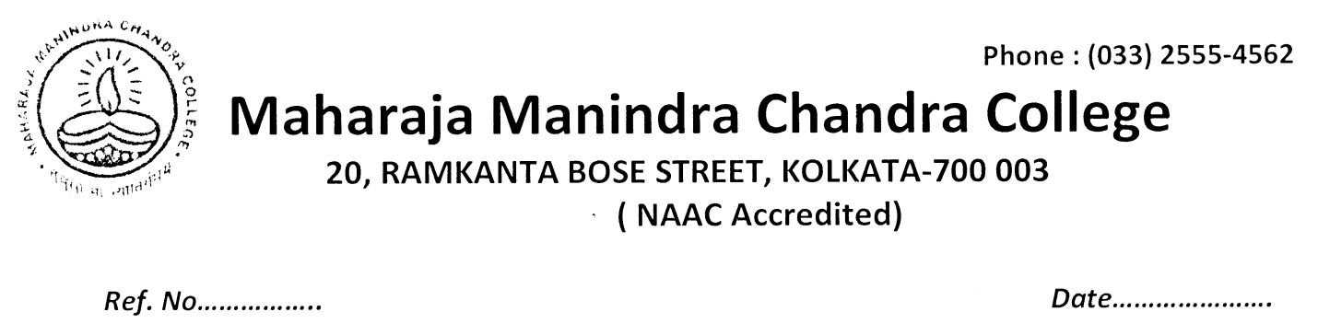
03.10.2020
NOTICE
Some candidates of the ongoing B.A/B.Sc/B.Com Part-III/Semester-VI Examination 2020 have submitted the hard copy of their answer scripts offline in the College office as per the following list. Departmental Heads/subject teachers are requested to collect those from the college office as early as possible.

DATE SUBJECT No. OF SCRIPTS
01.10.2020 B.Com (G) 02
MTMG 01
HISG 06
PLSG 02

03.10.2020 B.Com (G) 03
PHSG 01
PHIG 02
PLSG 02

Principal
M.M.C.College
Kolkata

